Solution of HON2 –

**Step -1 Create a Project –**

1. **In the left Navigation pane, click *Projects*, Click *Add*, Click *Create*.**
2. **Enter the following information and Click *Create*.**

**Step2- Create and Configure Connections**

Create File Server (FTP) Connection using FTP adapter

1. In the left Navigation pane, click *Projects*, click on the project which we have created.
2. In the Connections section, click *Add* to create a new connection.
3. Select the FTP Adapter.
4. From the *Create Connection* dialog, *Name* our connection as File Server and select *Role* as Invoke and leave the rest of the configurations as default. Click Create
5. Search for File, And click on File Server and click on Save. Exit the connection canvas by clicking the back button on the top left side of the screen
6. Enter the following configurations in the *FTP Connection* with the information we previously gathered from the File Server Settings page.
7. Confirm our Connection by clicking Test, then Diagnose & Test. we should see the *Connection File Server was tested successfully* confirmation message. Click Save and exit the Connection editor.

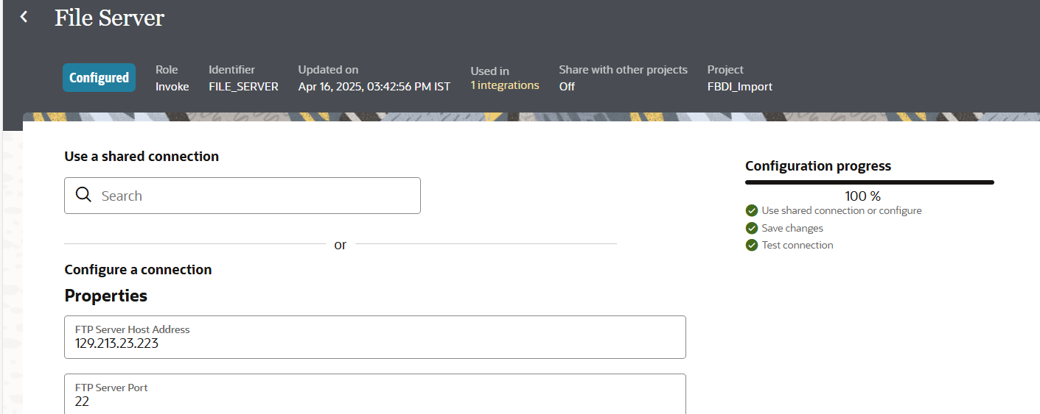

**Create ERP Cloud Connection using ERP Cloud adapter**

1. **In the left Navigation pane, click *Projects*, click on the project which we have created.**
2. **In the Connections section, click *Add* to create a new connection.**
3. **In the *Create Connection* dialog, select the *Oracle ERP Cloud* adapter to use for this connection. To find the adapter, enter ERP in the search field. Click on the highlighted adapter and enter the details.**
4. Click on **Test** and wait until we receive a confirmation box that the test was successful.
5. Click **Save** and wait for the confirmation box. Exit the connection canvas by clicking the back button on the top left side of the screen.

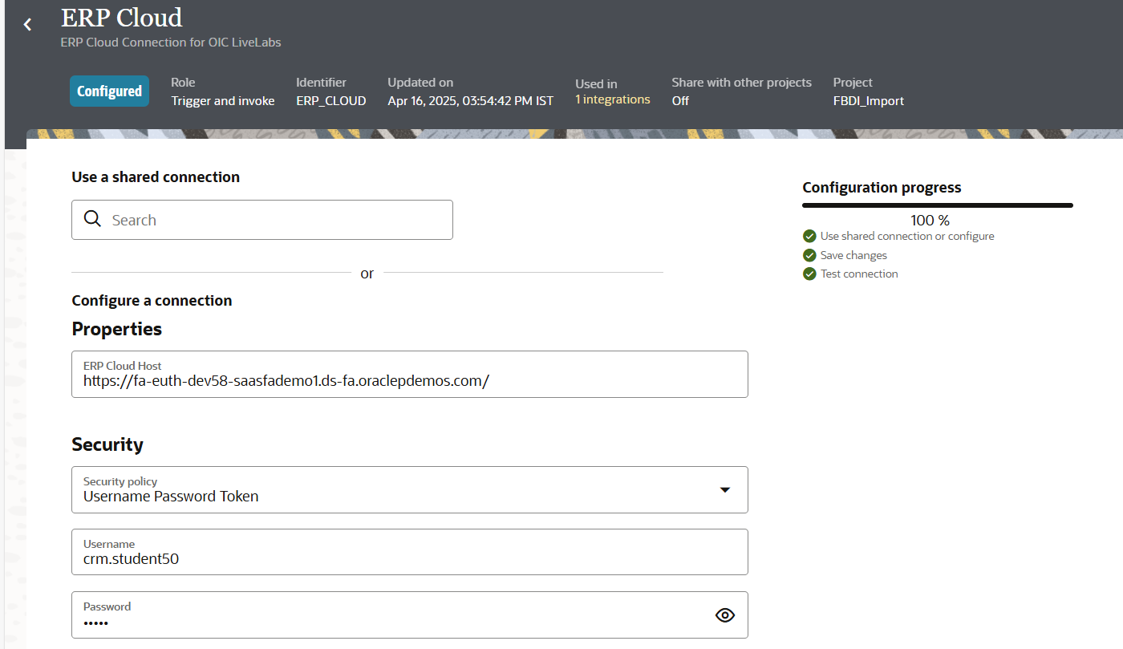

**Create FBDI file**

1. [Download the Invoice Import Template Spreadsheet](https://objectstorage.us-phoenix-1.oraclecloud.com/p/XZq0VjR0hhdCXW7I4oG3nAeKmewbevbf_N8MXjYuAd653nzyBYb5SDuQnsmvTqc7/n/oicpm/b/oiclivelabs/o/oic3/erp-cloud/GSEPayablesStandardInvoiceImportTemplate.xlsm)
2. [Download the APTEST.PROPERTIES file](https://objectstorage.us-phoenix-1.oraclecloud.com/p/ZYlgDcfOuHfuuyjwxsY1zcMPc25OYrXtKmu3pFSq1LLAedPnXp7N-p1ldj2FSElw/n/oicpm/b/oiclivelabs/o/oic3/erp-cloud/APTEST.PROPERTIES)
3. **Open GSEPayablesStandardInvoiceImportTemplate.**
4. **Go to the AP_INVOICES_INTERFACE sheet and update the following fields with unique random numbers:**
   * **Invoice ID**
   * **Invoice Number**
5. **Click on AP_INVOICE_LINE_INTERFACE sheet.**
6. **Enter the same invoice IDs that you used in the AP_INVOICES_INTERFACE sheet.**
7. ***Save* the file, Open the Instructions and CSV Generation Sheet and click *Generate CSV file*. A file browser dialog appears.**
8. **Name the zip file as apinvoiceimport.zip, save the AP_INVOICES_INTERFACE file as ApInvoiceInterface.csv, save the AP_INVOICE_LINE_INTERFACE file as APInvoiceLinesInterface.csv**
9. **Close the GSEPayablesStandardInvoiceImportTemplate.xlsm file**
10. **From File Explorer, copy the APTEST.PROPERTIES file to the apinvoiceimport.zip file.**

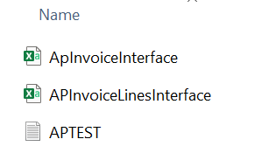

1. **Login to the FTP Server using WinSCP**
2. **Copy the apinvoiceimport.zip file to the following directory. /home/user1/ora038**

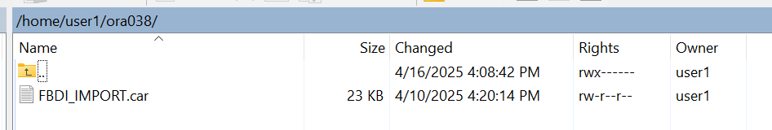

**Create the Invoice Bulk Import to ERP integration**

1. **In the left Navigation pane, click *Projects*, click on the project which we have created.**
2. **In the Integrations section, click *Add*.**
3. **On the *Add integration* dialog, click *Create*.**
4. **On the *Create integration* dialog, select and click on *Schedule***
5. **In the *Create integration* dialog, enter the following information:**

| **Table 1: Create integration** | |
| --- | --- |
| **Element** | **Value** |
| **Name** | **Invoice Bulk Import to ERP** |
| **Description** | **This integration demonstrates the use of OIC’s ERP Cloud Adapter with the FTP adapter to retrieve an AP Invoices file, import it to the ERP Cloud.** |

1. **Accept all other default values.**
2. **Click *Create*.**
3. **Optional, Select Layout to *Horizontal* and Click *Save* to apply changes.**

**Get the File from FTP Server**

1. **Click the *+* sign after Schedule in the integration canvas.**
2. **Select the FTP Connection which you have created in the previous labs. This invokes the FTP Adapter Configuration Wizard.**
3. **On the Basic Info page,**
   * **for the What do you want to call your endpoint? element, enter *ReadAPInvoicesFileFromFTP***
   * **for the What does this endpoint do? element, enter *Retrieves the AP Invoices that comply with FBDI from an FTP location.***
   * **Click *Continue*.**
4. **From the Operations page,**
   * **select *Read a File* as an Operation**
   * **from the Select a Transfer Mode option, select *ASCII***
   * **Enter the following values and Click *Continue*.**

| **Table 2: File Properties** | |
| --- | --- |
| **Element** | **Value** |
| **Input Directory** | **/home/user1/ora038** |
| **File Name** | **apinvoiceimport.zip** |

1. **Review the summary and click *Finish*.**
2. **Click *Save* to persist changes.**

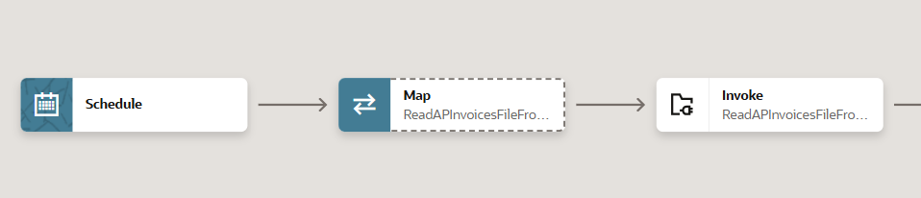

**Upload the file to ERP Cloud**

1. **Hover over the outgoing arrow for Invoke ReadAPInvoicesFileFromFTP and click + icon.**
2. **Begin typing ERP in the Search field to find the connection to your ERP Cloud.**
3. **Select the connection which you have created in the previous labs. The Configure Oracle ERP Cloud Endpoint wizard appears.**
4. **On the Basic Info page,**
   * **In the What do you want to call your endpoint? field, enter *ImportAPInvoicestoERPCloud***
   * **In the What does this endpoint do? field, enter: *Uploads files to UCM in ERP Cloud***
   * **Click *Continue*.**
5. **On the Actions page,**
   * **select *Import Bulk Data into Oracle ERP Cloud***
   * **Click *Continue*.**
6. **On the Operations page,**
   * **select *Import Payables Invoices* (Search for it)**
   * **Click *Continue*.**
7. **On the Response page, select the following options:**
   * **From the Notification Mode list, select *Email & Bell Notification***
   * **From the Occurrence list, select *Send in any case*.**
   * **Click *Continue*.**
8. **Review the summary and click *Finish*.**
9. **Click *Save* to persist changes.**

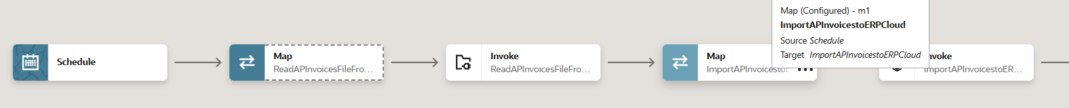

**Define the data Mapping**

1. **Select the action Map ImportAPInvoicestoERPCloud and click on … and click on Edit**
2. **In the Sources section successively expand the following elements:**

**a. ReadAPInvoicesFileFromFTP Response (FTP)**

**b. Sync Read File Response**

**c. File Read Response**

**d. ICS File**

1. **In the Target section successively expand the following elements:**

**a. Import Bulk Data**

**b. ICS File**

1. **Drag the File Reference element From the Sources section, and drop it on the element of the same name in the Target section.**
2. **In the Sources and Target sections expand Properties located under ICS File.**
3. **Drag the following elements from the Sources and drop them on the element of the same name in the Target section:**

**a. directory**

**b. filename**

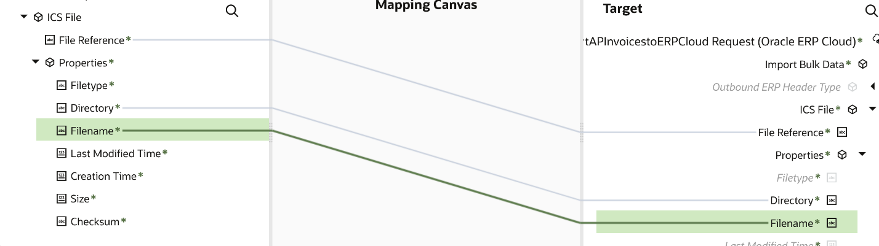

1. **Click on *Validate* A confirmation message appears.**
2. **Click *< (Go back)***
3. **Click *Save* to persist changes.**
4. Define Tracking Fields
5. In the **Integrations** section, Click on **…** of the Integration and click the **Activate** icon
6. On the **Activate Integration** dialog, select **a tracing level**, and click **Activate**.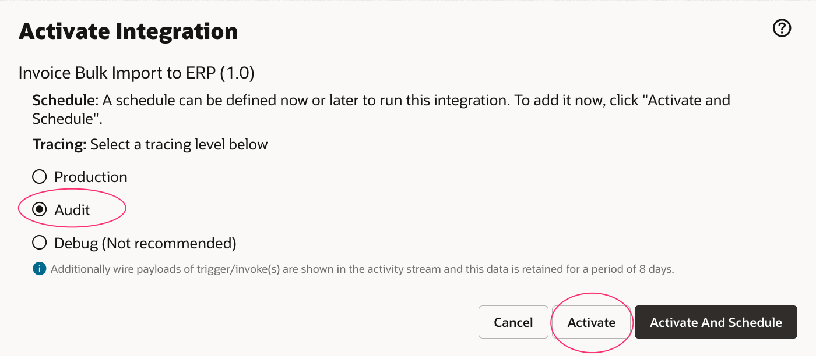
7. In the **Integrations** section, Click on **…** of the Integration and click on ***Run***
8. Click on ***Run*** again.
9. Click the link which appears on top to track the instance. The track instance page appears. The Integration state should be processing or successful. Importing of the invoices to the ERP Cloud might take few minutes. OR you can also track by clicking on ***Observe***, and ***Instances***

**Wait 5 minutes before performing this procedure.**

1. **Open a browser to sign in to the ERP Cloud using the information provided to us.** 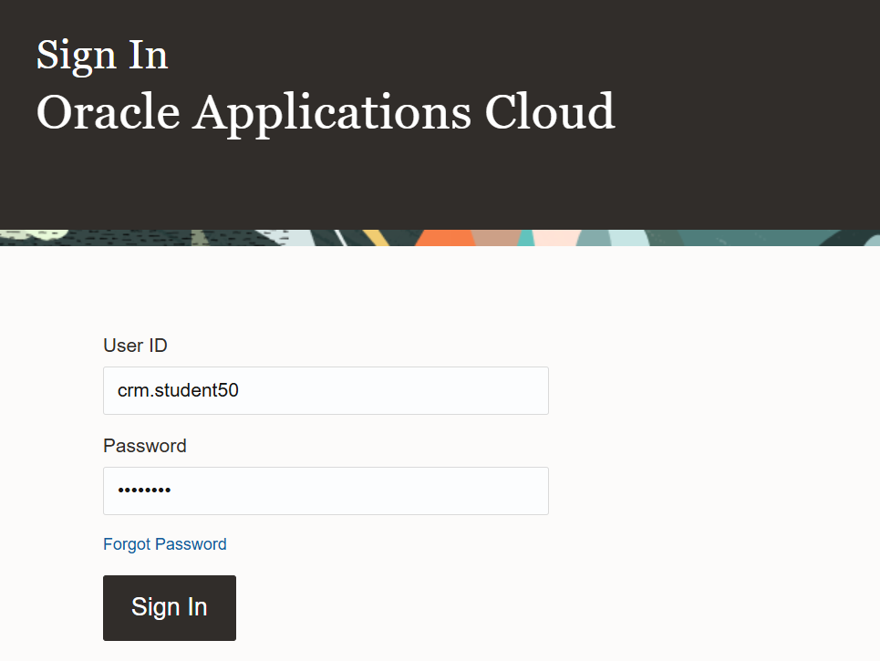
2. **Click on Navigator Menu(On top left corner), Click on Payables, click Invoices and Click on the search in the Details panel located below the User menu.**

1. **Enter the invoice number and click search. The invoice should appear in the search results.**

